**Simon ice breaker**

**Level 0:**

**1. My best score was 6**

**2. The best score in the group was 11**

**3. The games tests your skills to remember the coding of the game**

**4. It’s similar because it has controls, comes with audio and different levels to advance to.**

**1. We press buttons that has a specific coding that makes it eligible to play the game properly.**

**2. If correct, it will move on to the next button pattern. However, if incorrect you will hear a degrading buzzing audio that indicates that you have lost.**

**3. Red for passing on to others for each level or green for playing single player.**

**4. It stops the game, resulting in having to start the game over again by showing an “X” and enlightening the button.**

**Level 1:**

**1. Baer, Ralph H.**

**2. An Atari arcade game called, “Touch me”**

**3. Atari “Pong”**

**4. Pong and Space invaders**

**1. Playstation 1.**

**2. Old games have bad graphics and a very basic goal that you have to get. Current games now have an expanding control and new contents to it.**

**3. They still share the use of a control system and a basic idea of what the game really is.**

**Level 2:**

**1**

|  |  |  |
| --- | --- | --- |
| **Object** | **Action** | **Description** |
| **Red button** | **Touch** | **Start solo mode** |
| **Green button** | **Touch** | **Multiplayer mode** |
| **Small green button** | **Push** | **Turn on the game** |
| **Red button** | **Touch** | **Record a step in pattern** |
| **Green button** | **Touch** | **Record a step in pattern** |
| **Yellow button** | **Touch** | **Record a step in pattern** |
| **Blue button** | **Touch** | **Record a step in pattern** |

**2**

|  |  |  |
| --- | --- | --- |
| **Object** | **Action** | **Description** |
| **Red light** | **Flashes** | **Start solo mode** |
| **Green light** | **Flashes** | **Start Multiplayer** |
| **Red button** | **Plays Tone** | **Indicates a step in the pattern** |
| **Blue button** | **Plays Tone** | **Indicates a step in the pattern** |
| **Green button** | **Plays Tone** | **Indicates a step in the pattern** |
| **Yellow button** | **Plays Tone** | **Indicates a step in the pattern** |
| **Blue light** | **Flashes** | **Key to progress to next level** |
| **Yellow light** | **Flashes** | **Key to process to next level** |
| **Small green button** | **neutral** | **Button to turn on the game** |

**3**

|  |  |  |
| --- | --- | --- |
| **Object** | **output action** | **process connection** |
| **red button** | **red light** | **flashes when button is pushed (indicates step of pattern)** |
| **blue button** | **blue light** | **flashes when button is pushed ( indicates step of pattern)** |
| **green button** | **green light** | **flashes when button is pushed (indicates step of pattern)** |
| **yellow button** | **yellow light** | **flashes when button is pushed (indicates step of pattern)** |
| **small green button** | **simon game logo countdown** | **the Simon game logo appears on little screen to indicate the game is starting** |
| **wrong red button** | **Only red light/A Boop sound/ “X” shows on smaller screen** | **All other lights are off, while wrong red light stays on** |
| **wrong blue button** | **Only a blue light/A boop sound/ “X” Shows on smaller screen** | **All other lights are off, while wrong blue light stays on** |
| **Wrong Yellow light** | **Only Yellow light stays on/A boop sound/ “X” shows on small screen** | **All other lights are off while wrong yellow light stays on** |
| **Wrong Green light** | **Only green light stays on/A boop Sound/ “X” shows on smaller screen** | **All other lights are off while wrong green light stays on** |

**Level 3**

**1**

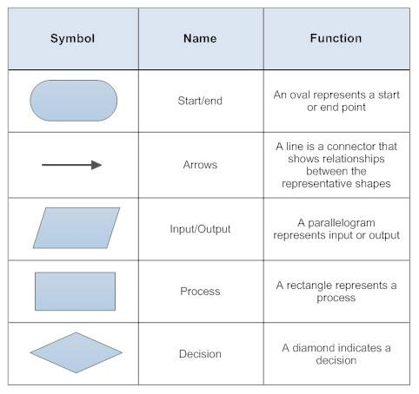

**2**